Custom Calendar Active Steps

1.Login to Sandbox and go to setup.
2. Click on object manager, search for Sales organization, and scroll down to validation rules. In validation rules open “Cannot_Change_Custom_Calendar” validation rule and uncheck the Active checkbox and click on save.
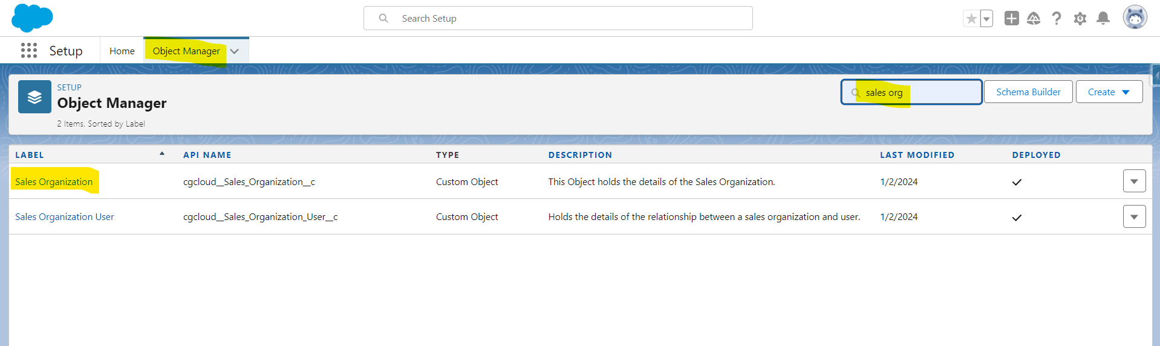
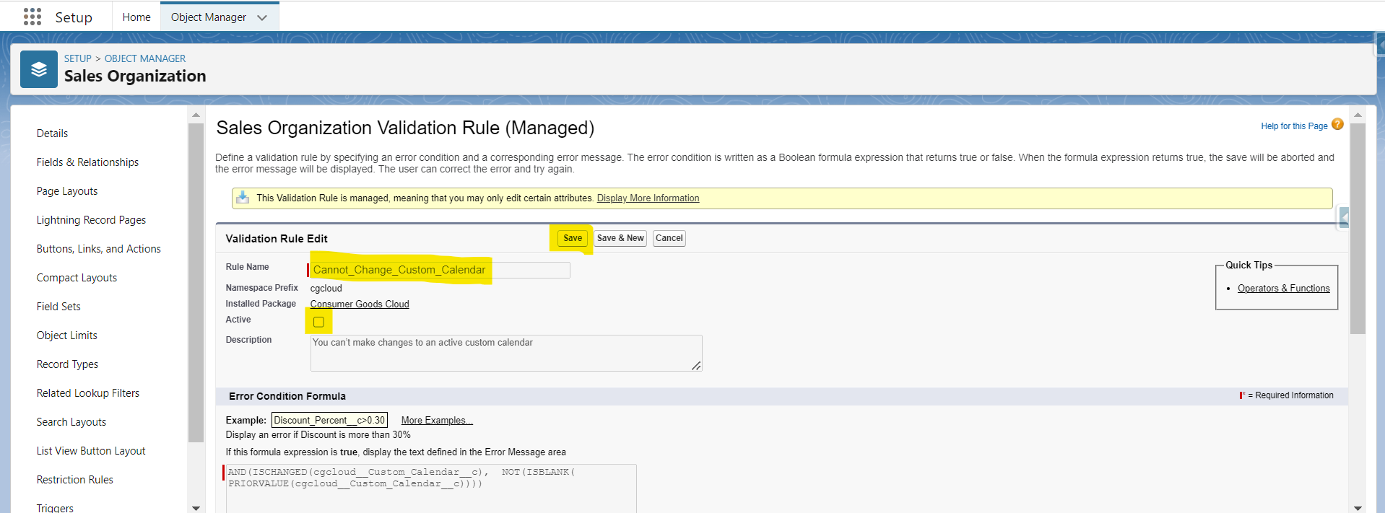

3.Go to App launcher (by clicking on Top left Six dots) and search for Sales organization and click on it.
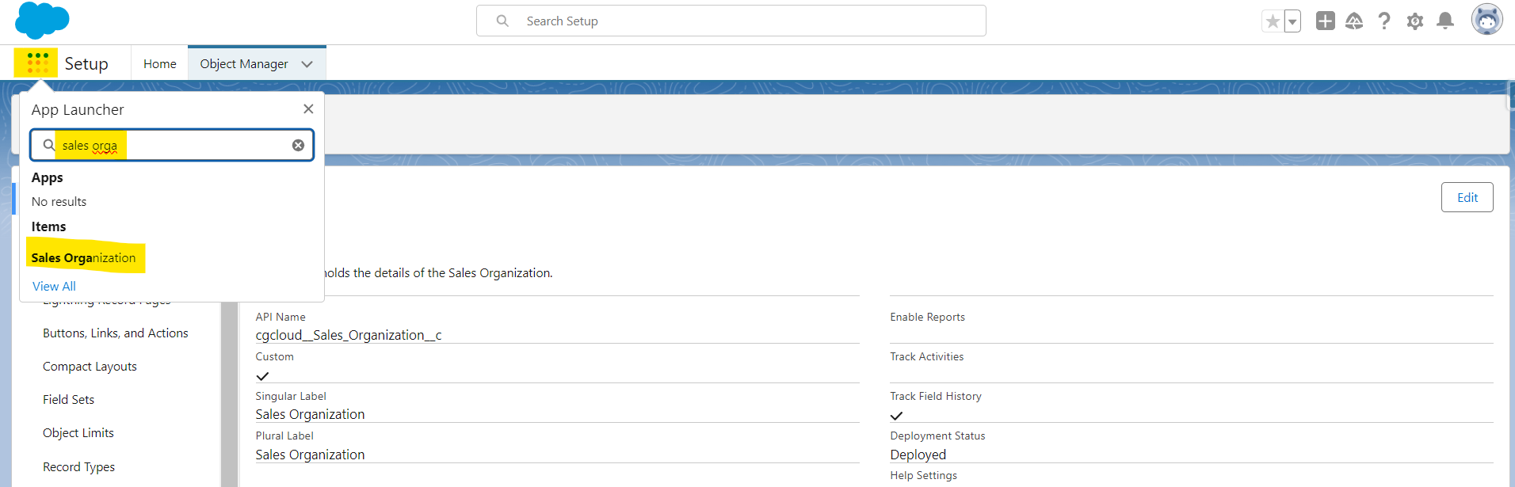

4.Scroll down to General settings and remove the CC-000 value from the Custom Calander field and click on Save.
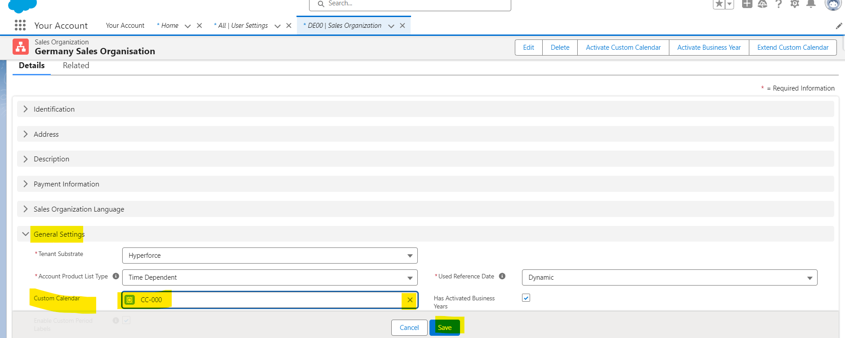

5.Now add back the Same value (CC-000) to Custom Calander field
Add Extenal Id--- CIM_Custom_Calendar_DE00 Click on Go---- > click on Save.
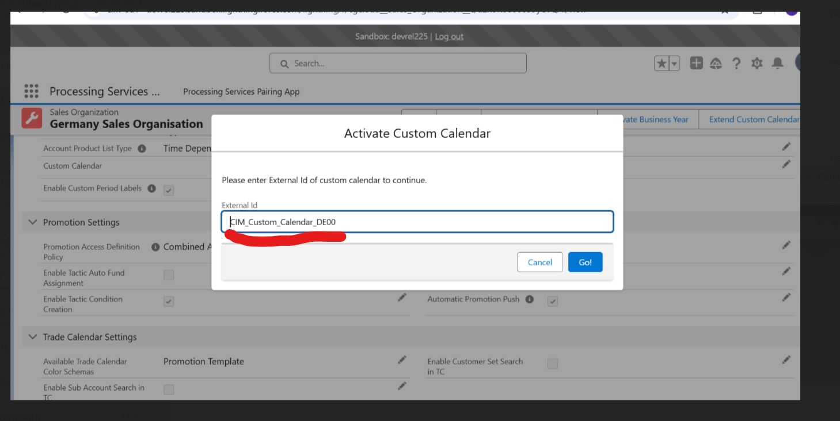
After saving it click on Active Custom Calander button at the top.
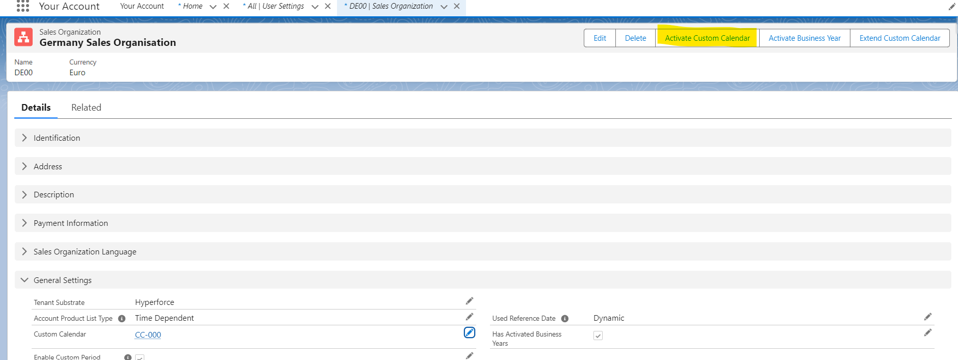
After activating custom Calander & Business Year ---- Click--- > Extend custom Calander---- click on Save..
6.Click on setup and Repeat Step 2 but instead Check the Active Check box for “Cannot_Change_Custom_Calendar” validation rule and click on save.
